**L D College of Engineering, Ahmedabad**

**Department of Information Technology**

**Academic Year :- 2021-22**



**GTU B.E. 7th Semester**

**3170001- Summer Internship**

**Subject / Topic : Python(Django)**

**INTRODUCTION TO ORGANIZATION**

**Akash Technolabs**

K-6, Shree Krishna Center Above Crossword Library Mithakhali Six Road, Navrangpura Ahmedabad, Gujarat, India – 380009

[**https://akashtechnolabs.com/**](https://akashtechnolabs.com/)

**Introduction**

* It is a website development company ,with 11 years of experience ,which holds a reputed image among contemporaries. They always try to provide best services to their clients.
* Website development of their firm is completely unique and adorable as well as original. They care for the trust that their clients have in them and so they assure clients to keep their quality up to the mark. They work on various website development projects on an international level too.
* They also hire new developers and give them golden opportunity to show their work and talent.
* They also give SEO services and Social Media Marketing to their clients. At Akash Technolabs they have highly professional and experienced team of developers.

**What they do ? :**

* Mobile Development
* Dynamic Website Development
* PHP Development
* Laravel Development
* Node JS Development
* Angular JS Development
* React Native Development

**On Which Technologies they work most:**

* Python
* Angular
* Node Js
* React Native
* Laravel
* Android
* IOS and Flutter
* Php, MongoDB

**Week 1**

Day 1 :-

What I learned ?:

* I learned basic Introduction of python programming language. In this I got basic idea about python like it is high-level, interpreted, object-oriented as well as scripting language.
* I also learned the most important and amazing features of python which may be the reason behind of its success at current technology driven.

1. Easy to learn
2. Easy to read
3. Easy to maintain
4. Portable
5. Free and open source and object oriented
6. Extensible and Embeddable

* I also came to know about in which field and which big-tech companies are using python to make their service effective.
* Trainer show how to install python setup and add to environment variable and run first program of hello world using notepad++ and command prompt.
* Then I learned about IDEs and Pycharm which is most usable IDE for python development. We also learned to install it and run our program of hello world in IDE (Pycharm).

**Task:** Make Simple Registration form in html using div/table tags.

* To complete this task, using div tags
* I also used bootstrap 4 as CSS framework to make this form good looking.
* I put 5 fields in this registration form.

1. Name
2. Email
3. Contact No.
4. Password
5. Repeat Password

* Link : <https://github.com/prakharninja0927/akash-internship-tasks/tree/main/task%201>

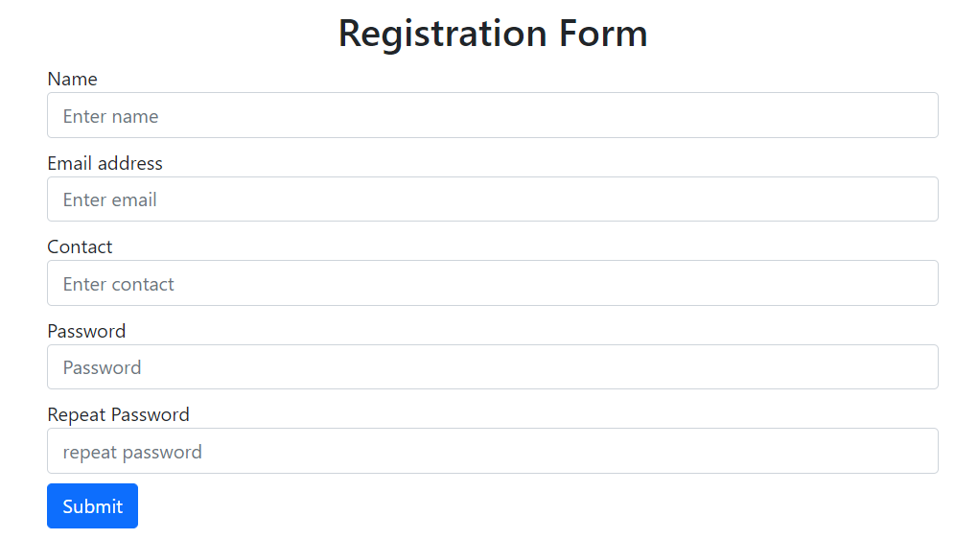

Day 2 :-

What I learned ? :

* In today’s session we get introduced to python variables, comments, and various data types and its methods.
* I learned mainly three ways to write down comments in python.

1. Using (#)
2. Using (‘’’)
3. Using (“””)

* Then we perform a task related to comments to make concept more clear practically.
* The we learned how name and declared variable that is used to store data in memory.
* Then we learned how to assign multiple variable and single value to multiple variable in single and perform task related to this.
* Then we get to know about standard data types of python programming language.
* We get small introduction and simple programs of all these datatypes.
* Some of these data types are very important in day to day life of any python developer like List, Tuple, Dictionary.
* Then we learned how to take a input from user with for loop and list method (lst.append(element)
* Then we learned various methods of tuple data type of python like wise we perform practicals of dictionary and its methods

Task: Python CRUD Operation using mysql.

* I used mysql-connector-python library to accomplish this given task.

Link: <https://github.com/prakharninja0927/akash-internship-tasks/tree/main/task%202>

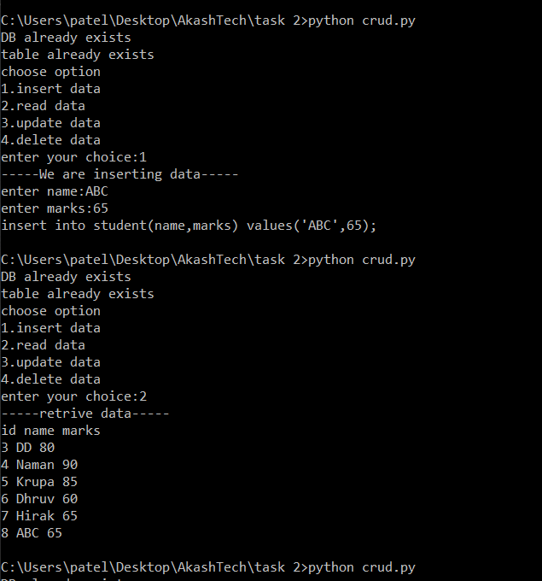

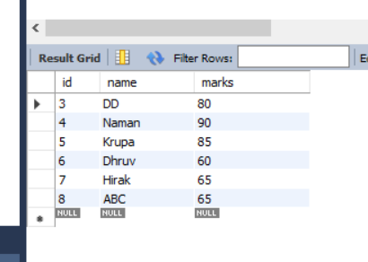

Day 3 :-

What I learned ?:

* I this session we are introduced to Input/Output functions input() and print() and their syntax.
* Then we learned Conditional Statements.

1. If statement.
2. If….else statement.
3. If…elif….else statement.
4. Nestef If statement.

* After that we practice some programs of all these conditional statements like check number is even or odd / +ve or -ve.
* After conditional statements we got introduced by for loop and perform task of print 1 to 100 using loop.
* We also learned how to use for loop for range() and lists.
* Before that we learned syntax of range() and for loop.
* Then we got to know about statements used in for loop like continue and break as well as pass.
* While learning them we learned terminologies of these statements for when and why we use these.
* Onward we also learned how to use loop with else. when condition of loop get to false else statement execute.

**Task:**

1. Calculate average of 5 numbers.
2. Check whether number is even or odd.
3. Take a year and check whether it is leap year or not
4. Take a number and check whether it is zero, positive or negative.
5. Take 2 numbers and display greatest number. (Also check equal number condition)
6. Take a number and find factorial of that number.
7. Write a program to swap 2 numbers using third variable.
8. Take 2 numbers and find smallest number.
9. Take a number check if a number is less than 100 or not. If it is less than 100 then check if it is odd or even.
10. Take a number to print the square of a number if it is less than 10.
11. Take a number and check whether it is zero, positive or negative using nested IF…ELSE statement .
12. Take 3 numbers and find greatest number using nested IF….ELSE statement.
13. Take 3 numbers and find smallest number using logical operator.
14. Write a program to swap 2 numbers without taking third variable.
15. Take starting number and ending number from the user and print following series.

30 27 24 21 18 15 12 9 6 3 0

Link: <https://github.com/prakharninja0927/akash-internship-tasks/tree/main/task%203>

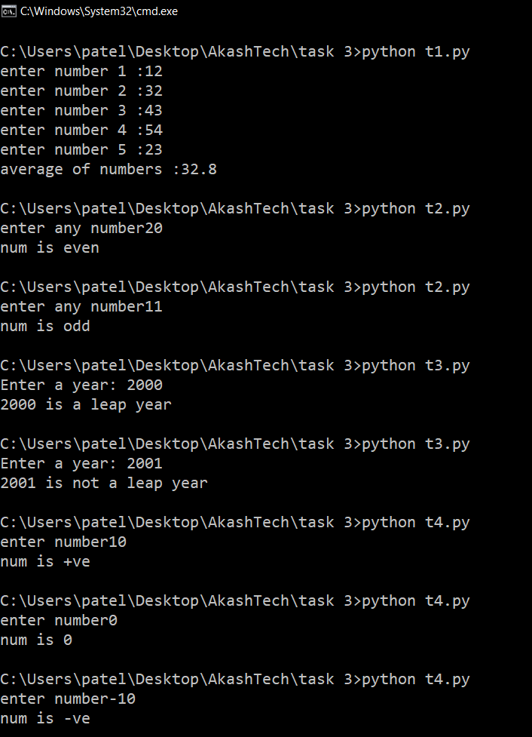

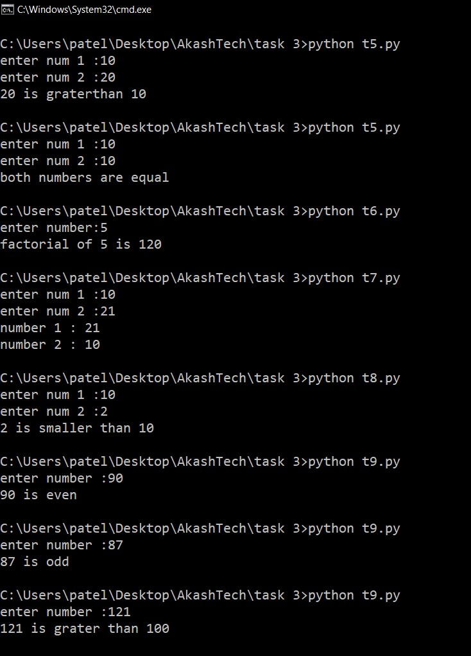

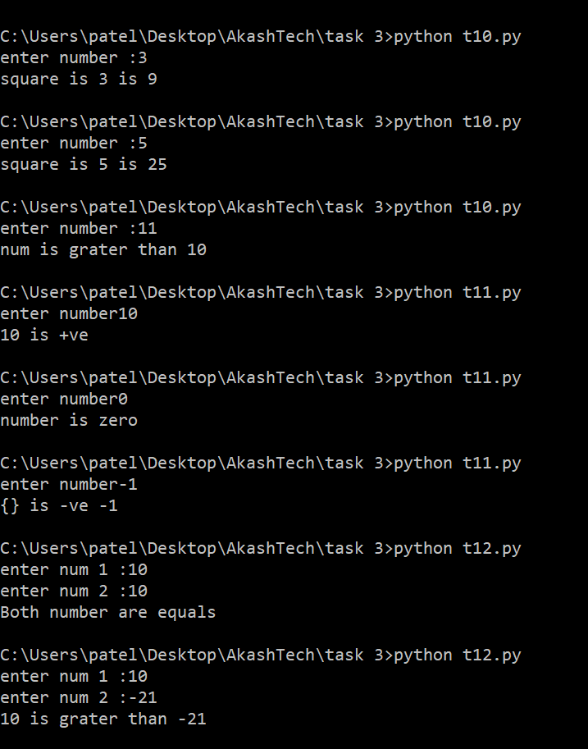

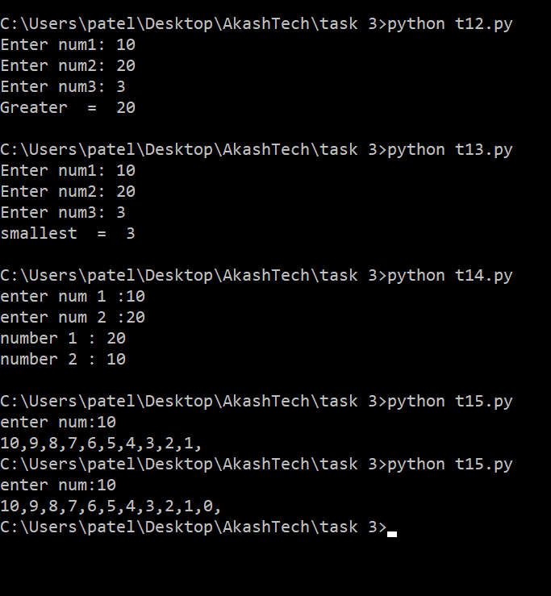

Day 4 :-

What I learned ? :

* On this day we learned the most important feature of any programming language which is also extended in Python too which is “Functions”
* In today’s session we get to know about moto behind usage of function which is to perform specific task of any program.
* Then we learned syntax of defining function in python programming language.
* Any function is divided in small parts

1. “def” keyword
2. Function name
3. (arguments)
4. “:” symbol
5. Function “body”.
6. Return statement (optional)

* We also learned about three different types of arguments which can be provided in python function

1. Default arguments
2. Keyword arguments
3. Variable-Length arguments

* We perform all types of arguments program to understand well and this helps us in remembering for long time.
* We also learned about non keyword arguments as well as keyword arguments where in non keyword we provide arguments without using argument name where as in keyword arguments we provide arguments name which is defined in calling function.
* Then after we get the information about Scope of variable which is mainly two typed 1

1. Global Variable
2. Local variable

* Variables that are defined inside a function body have a local scope, and those defined outside have a global scope.
* We also get the information about ‘indentation error: expected an indented block’
* After that we get to know about module functionality of python programming.
* That are used to break down big programs in small ones as well as make program or project organized.
* We can define our most used functions in a module and import it, instead of copying their definitions into different programs. We also perform example program.
* Then we dived into operator world and get information about how may type of various operators exists in python programming language.

1. Arithmetic
2. Comparison
3. Logical
4. Assignment
5. Membership
6. Identity

* Arithmetic operators are used to perform arithmetic computing(add, subtract, multiply, Division etc…)
* Logical operators(and,or,not) are used to accomplish logical tasks.
* Like wise we have done all program of these operators.

**Task:-** Perform all program performed in session

